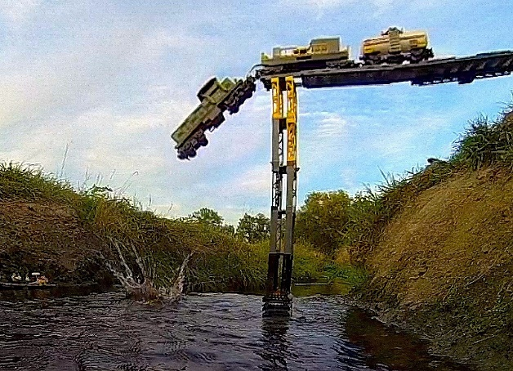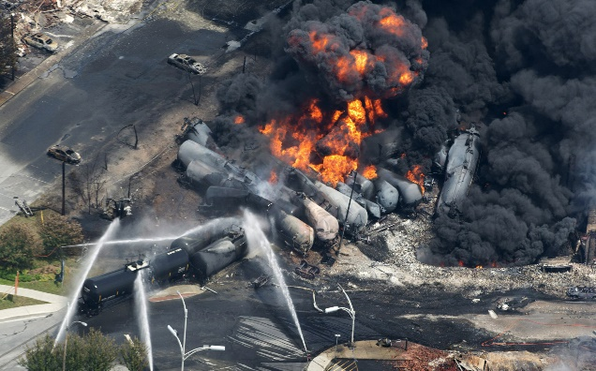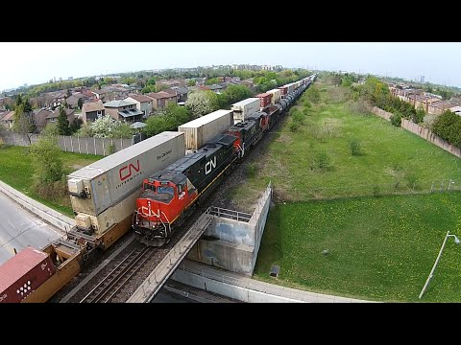

Train Safety System (TSS)

**Final Qualification Test**

December 9, 2016

Adam Colwell

Michael Jones

Valentine Nwachukwu

Richard Oteri

**Final Qualification Test Signature Block**

|  |  |  |
| --- | --- | --- |
| **Name** | **Signature** | **Date** |
| Adam Colwell |  |  |
| Michael Jones |  |  |
| Valentine Nwachukwu |  |  |
| Richard Oteri |  |  |

**Table of Contents**

1 Concept of Operations (CONOPS) 1

2 TSS Installation Instructions 1

2.1 Hardware Requirements 1

2.2 Software Requirements 1

2.3 Installation Instructions 1

2.3.1 Hardware Installation 1

2.3.2 Software Installation 1

2.3.3 Running the TSS Software 3

3 Test Plan 3

4 Test Case Descriptions 3

4.1 Initialization Tests 4

4.2 Switch Configuration Tests 5

4.3 Occupancy Data Tests 6

4.4 Collision Dialog Tests 6

4.5 Endpoint Section Collision Tests 7

4.6 Straight Section Collision Tests 7

4.7 Switch Section Collision Tests 8

4.8 Crossover Section Collision Tests 9

4.9 Short Section Collision Tests 10

4.10 Random Collision Tests 11

5 Final Qualification Test Report 12

6 Glossary 13

7 References 14

**Table of Figures**

Figure 1: TSS Software Package Visualization 2

**Revision History**

|  |  |  |  |
| --- | --- | --- | --- |
| **Name** | **Date** | **Reason for Changes** | **Version** |
| Michael Jones | 10-31-2016 | Initial Template | 0.1 |
| All | 11-22-2016 | Made Progress on Each Section | 0.2 |
| Michael Jones | 11-25-2016 | First Integration of Document | 0.3 |
| Valentine Nwachukwu | 11-26-2016 | Modified Initialization and Occupancy Section, HW & SW Requirement, Dialog section and Modified CONOPS to include Raspberry Pi binding | 0.4 |
| Valentine Nwachukwu | 12-3-2016 | Added references | 0.5 |
| All | 12-3-2016 | Performed Final Integration | 1.0 |

# Concept of Operations (CONOPS)

The Train Safety System (TSS) is a software system designed to prevent train collisions in LocoNet, a digitrax HO model track and supporting digitrax hardware. Specifically, it was generated as a multi-threaded program which provides an anti-collision safety system for Loco trains for the UAH's (University of Alabama in Huntsville) train safety system lab. At this current version, TSS was written to run on a Raspberry Pi 3 running Raspbian Jessie – a variation of Debian (8.0) Jessie.

# TSS Installation Instructions

Within this section, the hardware and software requirements are described as well as the instructions to install the TSS software.

## Hardware Requirements

1. The Raspberry Pi 3 must have at least 1 GB of RAM available to fully support the Quality of Service (QoS) provided by TSS.
2. The Raspberry Pi 3 must also have at least 5 MB of free hard drive space.

## Software Requirements

Before installing TSS, the following software and configuration must be enabled at the target system.

* + - 1. Linux – Debian (8.0) Jessie – For Raspberry Pi 3 this is Raspbian Jessie.
      2. Installation of Qt 5.4 or greater (provided by installation script).
      3. Internet connection is needed for installing TSS for the first time, ensure that wifi is connected. **(Student 5 should do.)**

## Installation Instructions

### Hardware Installation

Connect the Loconet PR3 connect to one of the Raspberry Pi’s RS485 (usb) port. This will form a COM port between Loconet and the Raspberry Pi. Next, plug in the Ethernet cable in the safety system lab to the Raspberry Pi. This Ethernet cable connects to the lab’s UAH Intranet which has linkages to the Arduino Safety Systems (star→ 172.21.0.64 and stal → 172.21.0.63).

### Software Installation

Insert the USB drive that is storing the TSS software (the TSS executable, the TSS start script, Sections.txt, etc.) into the system, through a USB port, that will be running the TSS software. With the TSS software USB inserted into the system, extract the zip folder named *cpe656safetysystem-train-safety-system-{*checksum*}.zip* to a desired location.

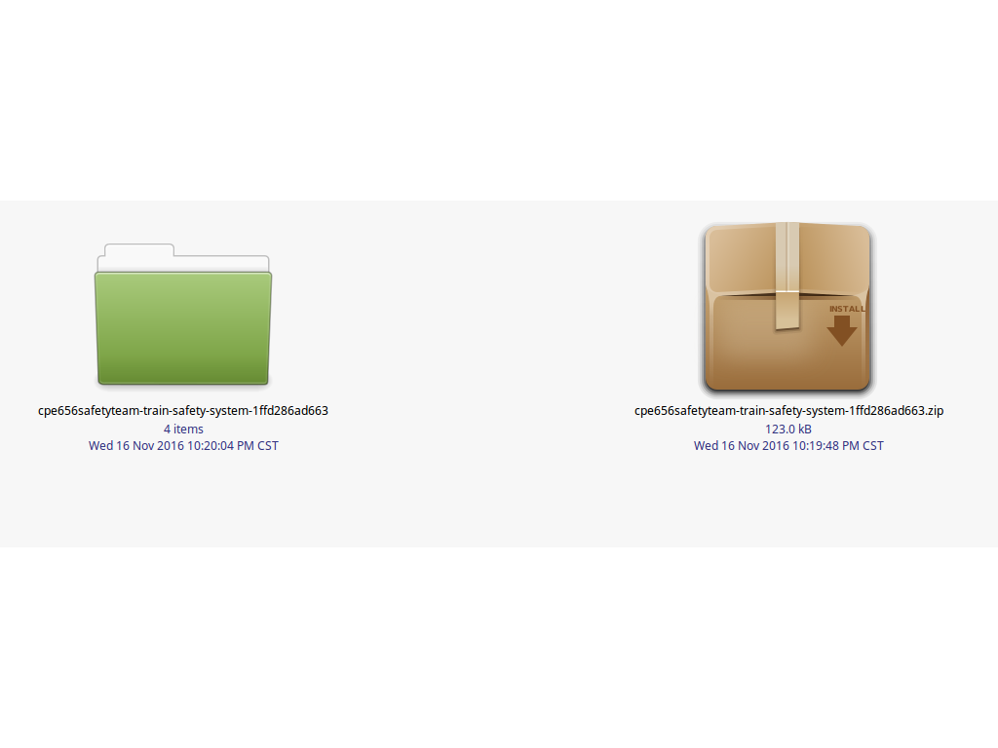

Figure 1: TSS Software Package Visualization

Open the extracted folder and then navigate to the TSS folder.

Before beginning installation, it is necessary to set permissions on the installation script through the following command:

chmod +x install_TSS.sh

then run ./install_TSS.sh to begin installation. The installation script is detailed below

#/bin/bash

#######################################################################

# Author: Valentine C. Nwachukwu

# Email: valdiz777@gmail.com

# DESC: This is a TSS setup script for Debian Jessie

################################# Pre-Reqs ##############################

echo "Installing Pre-Reqs"

echo "==================="

sudo apt-get install -y build-essential

########################### Install Qt5Defaults ############################

echo "Installing Qt5Defaults"

echo "========================="

sudo apt-get install -y qt5-default

cd TSS

tss_dir=`pwd`

chmod +x startTSS.sh

qmake TSS.pro

make

echo "Done installing TSS: Train Safety System..."

echo "Creating Alias for TSS"

echo "======================"

if [ -f ~/.bash_aliases ];

then

echo "File ~/.bash_aliases exists."

echo "alias TSS=\"cd $tss_dir/build/debug && ./../../startTSS.sh\"" >> ~/.bash_aliases

else

echo "File ~/.bash_aliases does not exist."

echo "alias TSS=\"cd $tss_dir/build/debug && ./../../startTSS.sh\"" >> ~/.bash_aliases

fi

echo "All systems are a go. type TSS to begin..."

### Running the TSS Software

Open up a terminal and type **TSS** to start the software. If you have the shell open from installation you will need to type **bash** to create a new instance or **source ~/.bash_aliases** in order to propagate the alias setting done in the installation script

# Test Plan

Within the following test cases, the TSS group plans to test each aspect of the TSS software to prove that it is functioning properly. The tests will begin with aspects of the software that must function properly in order for other functionality of the software to perform as designed (initialization tests, switch configuration tests, occupancy data tests, and collision dialog tests). After the initial test cases have been completed, it is time to move onto the various test cases corresponding to the different types of sections available on the track (endpoint section collision tests, straight section collision tests, switch section collision tests, and crossover section collision tests). The final test that will be performed on the TSS software is a random collision test that will allow the user to perform his or her own test scenario (starting multiple trains on the track and continuing to run the trains until the user decides to try to crash the trains).

# Test Case Descriptions

The following subsections will go into detail on the tests that the TSS group determined would be sufficient to test all available functionality within the TSS software. Where the group has laid out a test plan and test descriptions, the group knows there are many more test cases that could be described and tested. The tests that have been provided are only a subset of all available tests.

## Initialization Tests

| Step Number | Actions | Expected Result | Actual Result | Pass / Fail |
| --- | --- | --- | --- | --- |
|  | Perform the lab setup steps (hardware configuration, software configuration, and starting the TSS software) outlined in the TSS User Manual. | The lab environment is set up and is ready to perform the test case. |  |  |
|  | Plug in the Ethernet cable in the safety system lab to the Raspberry Pi. This Ethernet cable connects to the lab’s UAH intranet which has linkages to the Arduino Safety Systems (star→ 172.21.0.64 and stal → 172.21.0.63) | Ethernet cable is physically connected to Raspberry Pi’s RJ45 port. |  |  |
|  | Perform a ping test on 172.21.0.63 (1) Open a terminal in the Pi, (2) enter the following command: ***ping 172.21.0.63***  *Then terminate when you see at least 10 successful pings.* | The console should display multiple entries of the following (starting at the “64 Bytes...” line), if the ping is successful: **PING 172.21.0.63 (172.21.0.63) 56(84) bytes of data 64 Bytes from 172.21.0.63: icmp_seq=1 ttl=64 time=x.xxx ms** |  |  |
|  | Perform a ping test on 172.21.0.64 (1) Open a terminal in the Pi, (2) enter the following command: ***ping 172.21.0.64***  *Then terminate when you see at least 10 successful pings.* | The console should display multiple entries of the following (starting at the “64 Bytes...” line), if the ping is successful: **PING 172.21.0.64 (172.21.0.64) 56(84) bytes of data 64 Bytes from 172.21.0.63: icmp_seq=1 ttl=64 time=x.xxx ms** |  |  |
|  | Turn on the track and then use the following command **echo BoardSection0 | netcat 172.21.0.63/64 23** to turn off a particular track section. Example **echo 351 | netcat 172.21.0.63 23** will turn off the track section labeled 3-6 in the track. | Selected track section will be powered off. Ensure this by placing the conductivity train → lights dimly red when a track section is off. Often in times, it won’t light up at all. Varies from track section to track section. |  |  |
|  | Set a turnout switch (**67**) to the **closed** configuration. | This can be verified through JMRI loconet and the track map on the computer running JMRI will show the switch turnout as closed |  |  |
|  | *NOTE: If the current terminal was used to perform the installTSS.sh script, perform the*  ***source ~/.bash_aliases*** *command.*  Start TSS by opening a terminal and executing the **TSS** alias | The TSS software will now be launched and you will see the graphical user interface for TSS which shows port selection (auto selected at either **ttyACM1** or **ttyACM0** depending on which PR3 is connected to the pi). |  |  |
|  | Press the Connect button | At the end of initialization, a pop-up should come up that says **System Initialization Complete! Initialization finished. System is Ready!** The selected section (3-6) on the track will now be turned on: Ensure this by placing the conductivity train → lights fully red when a track section is on. Selected turnout switch will be in a **thrown** state. The track map on the computer running JMRI will show the switch turnout state as **thrown**. |  |  |
|  | Select the Disconnect button | The test has been completed |  |  |

## Switch Configuration Tests

| Step Number | Actions | Expected Result | Actual Result | Pass / Fail |
| --- | --- | --- | --- | --- |
|  | Perform the lab setup steps (hardware configuration, software configuration, and starting the TSS software) outlined in the TSS User Manual. | The lab environment is set up and is ready to perform the test case. |  |  |
|  | Using a preferred method to control the track (digitrax track controller in our case), close switch 11. | The following message will displayed to the user and will be logged to the TSS log file:  “New Switch Data at Monitor for Turnout: 11 Closed_State: true” |  |  |
|  | Using a preferred method to control the track (digitrax track controller in our case), close switch 11. | The following message will displayed to the user and will be logged to the TSS log file:  “New Switch Data at Monitor for Turnout: 11 Closed_State: false” |  |  |
|  | Select the Disconnect button | The test has been completed |  |  |

## Occupancy Data Tests

| Step Number | Actions | Expected Result | Actual Result | Pass / Fail |
| --- | --- | --- | --- | --- |
|  | Perform the lab setup steps (hardware configuration, software configuration, and starting the TSS software) outlined in the TSS User Manual. | The lab environment is set up and is ready to perform the test case. |  |  |
|  | Move trains through the train track sections. | TSS will display occupancy (**New Occupancy Data at Monitor: “<section name>” State: true**) and vacancy (**New Occupancy Data at Monitor: “<section name>” State: false**) data at each track section the train passes through in the TSS debug logs and the TSS GUI console and sorted tabs. |  |  |
|  | Select the Disconnect button | The test has been completed |  |  |

## Collision Dialog Tests

| Step Number | Actions | Expected Result | Actual Result | Pass / Fail |
| --- | --- | --- | --- | --- |
|  | Perform the lab setup steps (hardware configuration, software configuration, and starting the TSS software) outlined in the TSS User Manual. | The lab environment is set up and is ready to perform the test case. |  |  |
|  | Create a collision scenario with the trains and tracks then run the train(s) to cause the TSS train monitoring algorithm to issue a collision event. For example, create an endpoint collision scenario. | The collision dialog will be presented with a collision event. The dialog will show all affection collision locations. The dialog will show the following information for collision event types → **<Collision Type> Collision Event Detected! Resolve collisions at section(s) <collision sections>.**  ***For example:* Endpoint Collision Event Detected! Resolve collisions at section(s) 1-9.** |  |  |
|  | Display of dialog is paired with a disablement of involved sections. Run the power testing train through the involved sections to verify power off. | Involved sections will be turned off. Power testing train will show a dim light with little to no luminance at each location. |  |  |
|  | Select the Disconnect button | The test has been completed |  |  |

## Endpoint Section Collision Tests

| Step Number | Actions | Expected Result | Actual Result | Pass / Fail |
| --- | --- | --- | --- | --- |
|  | Perform the lab setup steps (hardware configuration, software configuration, and starting the TSS software) outlined in the TSS User Manual. | The lab environment is set up and is ready to perform the test case. |  |  |
|  | Place a single stationary train on the track at section 1-16 with the front of the train pointing in the direction of section 1-9. | The stationary train is on section 1-16 and is ready to begin the test. |  |  |
|  | Start moving the train in the forward direction. | The train continues to move in a forward direction. |  |  |
|  | The train will continue to move in a forward direction until section 1-9 is reached. At this point, the TSS train safety algorithm will report a collision event. | The collision dialog will be presented with a collision event at section 1-9. |  |  |
|  | Select the Disconnect button | The test has been completed |  |  |

## Straight Section Collision Tests

| Step Number | Actions | Expected Result | Actual Result | Pass / Fail |
| --- | --- | --- | --- | --- |
|  | Perform the lab setup steps (hardware configuration, software configuration, and starting the TSS software) outlined in the TSS User Manual. | The lab environment is set up and is ready to perform the test case. |  |  |
|  | Place a single stationary train on the track at section 1-11 with the front of the train pointing in the direction of section 4-13. | The stationary train is on section 1-11 and is ready to begin the test. |  |  |
|  | Place a single stationary train on the track at section 1-8 with the front of the train pointing in the direction of section 1-15. | The stationary train is on section 1-8 and is ready to begin the test. |  |  |
|  | Start moving each train in the forward direction. | The trains continue to move in a forward direction. |  |  |
|  | The trains will continue to move in a forward direction until one of the trains reach section 4-13 or 1-15. At this point, the TSS train safety algorithm will report a collision event. | Depending on which train enters the “danger zone” last, there will be two possible collision events that can be reported. The collisions will either be reported when the first train reaches section 4-13 or the second train reaches section 1-15. In these cases, the collision dialog will be presented with a collision event at sections 4-13, 1-11, and 1-15 or sections 1-8, 1-15, and 4-13, respectively. |  |  |
|  | Select the Disconnect button | The test has been completed |  |  |

## Switch Section Collision Tests

| Step Number | Actions | Expected Result | Actual Result | Pass / Fail |
| --- | --- | --- | --- | --- |
|  | Perform the lab setup steps (hardware configuration, software configuration, and starting the TSS software) outlined in the TSS User Manual. | The lab environment is set up and is ready to perform the test case. |  |  |
|  | Place a single stationary train on the track at section 8-6 with the front of the train pointing in the direction of section 5-3. | The stationary train is on section 8-6 and is ready to begin the test. |  |  |
|  | Place a single stationary train on the track at section 5-16 with the front of the train pointing in the direction of section 5-4. | The stationary train is on section 5-16 and is ready to begin the test. |  |  |
|  | Using a preferred method to control the track (digitrax track controller in our case), close switch 61. | The switch will be closed and is ready to begin the test. |  |  |
|  | Start moving each train in the forward direction. | The trains continue to move in a forward direction. |  |  |
|  | The trains will continue to move in a forward direction until one of the trains reach section 5-3. At this point, the TSS train safety algorithm will report a collision event. | The collision dialog will be presented with a collision event at sections 5-4, 5-3, 5-13, and 5-14. |  |  |
|  | Select the Disconnect button | The test has been completed |  |  |

## Crossover Section Collision Tests

| Step Number | Actions | Expected Result | Actual Result | Pass / Fail |
| --- | --- | --- | --- | --- |
|  | Perform the lab setup steps (hardware configuration, software configuration, and starting the TSS software) outlined in the TSS User Manual. | The lab environment is set up and is ready to perform the test case. |  |  |
|  | Place a single stationary train on the track at section 5-16 with the front of the train pointing in the direction of section 5-14. | The stationary train is on section 5-16 and is ready to begin the test. |  |  |
|  | Place a single stationary train on the track at section 2-6 with the front of the train pointing in the direction of section 2-12. | The stationary train is on section 2-6 and is ready to begin the test. |  |  |
|  | Using a preferred method to control the track (digitrax track controller in our case), close switch 61. | The switch will be closed and is ready to begin the test. |  |  |
|  | Start moving each train in the forward direction. | The trains continue to move in a forward direction. |  |  |
|  | The trains will continue to move in a forward direction until the trains reach sections 5-4 and 5-3. At this point, the TSS train safety algorithm will report a collision event. | In this case (a crossover collision event), there will be two collision dialogs that will represent the two different types of crashes that were prevented (a crossover and either a straight or switch). To prevent duplication between the two dialogs, all sections that correspond to the straight section or switch section will be presented within that dialog. All other offending sections will be presented within the crossover dialog. Within this collision event, sections 2-12, 2-13, 5-4, and 8-1 will be reported and shut down in either case. If the collision event contains the switch section, the remaining sections that will be shut down are sections 2-10 and 2-11. If the collision event contains the straight section, the remaining section that will be shut down is section 5-3. |  |  |
|  | Select the Disconnect button | The test has been completed |  |  |

## Short Section Collision Tests

| Step Number | Actions | Expected Result | Actual Result | Pass / Fail |
| --- | --- | --- | --- | --- |
|  | Perform the lab setup steps (hardware configuration, software configuration, and starting the TSS software) outlined in the TSS User Manual. | The lab environment is set up and is ready to perform the test case. |  |  |
| 2. | Place a single stationary train on the track at section 4-13 with the front of the train pointing in the direction of section 1-7. | The stationary train is on section 4-13 and is ready to begin the test. |  |  |
| 3. | Place a single train stationary on the track at section 4-1 with the front of the train pointing in the direction of section 1-15. | The stationary train is on section 4-1 and is ready to begin the test. |  |  |
| 5. | Start moving each train in the forward direction. | The trains continue to move in a forward direction. |  |  |
|  | The trains will continue to move in a forward direction until the trains reach sections 1-7 and 1-15. At this point, the TSS train safety algorithm will report a collision event. | The collision dialog will be presented with a collision event at sections 1-7, 1-8, and 1-15. |  |  |
|  | Select the Disconnect button | The test has been completed |  |  |

## Random Collision Tests

| Step Number | Actions | Expected Result | Actual Result | Pass / Fail |
| --- | --- | --- | --- | --- |
|  | Perform the lab setup steps (hardware configuration, software configuration, and starting the TSS software) outlined in the TSS User Manual. | The lab environment is set up and is ready to perform the test case. |  |  |
| 2. | Place a single stationary train on the track at a random section. | The stationary train is on a random section and is ready to begin the test. |  |  |
| 3. | Place another single stationary train on the track at a random section. | The stationary train is on a random section and is ready to begin the test. |  |  |
| 4. | Using the JMRI, allow the trains to move on their own without a collision being wrongfully reported. | The trains continue to move on the track. |  |  |
| 5. | When ready to perform the collision test, move the trains toward each other until a collision is reported. | The collision dialog will be presented with a collision event at the sections corresponding to the crash scenario. |  |  |
|  | Select the Disconnect button | The test has been completed |  |  |

# Final Qualification Test Report

< We need to talk about how we did all of the test cases described above and how they worked perfectly as intended >

# Glossary

|  |  |
| --- | --- |
| **Term** | **Definition** |
| **CONOPS** | Concept of Operations. The high-level description of a system from the perspective of a user of the system. |
| **Crossover Section** | A section that is part of a crossover. In this case, trains on tracks on the left and right of the current section must be considered when detecting and preventing a collision. |
| **Digitrax** | The train control system used to drive the trains on the track. |
| **Endpoint Section** | A section that contains only one connection and is one of the end points of the track. |
| **JMRI** | Interface between the train track and the TSS software. |
| **Loconet** | HO model track and supporting digitrax hardware. |
| **Short Section** | A section that would be too short to detect and prevent a collision if treated the same as other sections. |
| **Straight Section** | A section that contains two connections. |
| **Switch Section** | A section that contains three connections. If the switch is configured for one direction at the fork, the power to the other direction of the fork is removed (track design, not part of the TSS software). |
| **TSS** | Train Safety System |

# References

[1] "Digitrax Specification 1.0". Digitrax. N.p., 2016. Web. http://www.digitrax.com/static/apps/cms/media/documents/loconet/loconetpersonaledition.pdf

[2] Colwell, Adam. Jones, Michael. Nwachukwu, Valentine. Oteri, Richard. “TSS User Manual,” 2016.